Experiment 10: L2, Dropout and Early Stopping Comparison

1. Aim
To analyze and reduce overfitting in a Multilayer Perceptron (MLP) model used for diabetes prediction. To train a large baseline neural network, apply L2 regularization with different lambda values, compare dropout rates of 0.2, 0.3 and 0.5, and implement early stopping using validation loss. To evaluate and compare the models using training accuracy, test accuracy and train–test accuracy gap with TensorFlow, Keras, NumPy and Matplotlib.

2. Formula(s)
1. Binary Cross-Entropy Loss: L = -(1/N) × Σ [yi × log(pi) + (1-yi) × log(1-pi)]
2. L2 Regularization: L_total = L_original + λ × Σ(wi²)
3. Dropout: Output = Input × Mask / (1 - Dropout Rate)
4. Early Stopping: Stop training when validation loss does not improve for a specified number of epochs.
5. Accuracy: Accuracy = (TP + TN) / (TP + TN + FP + FN)
6. Train-Test Gap: Train-Test Gap = Training Accuracy - Test Accuracy

3. Overall Flow Diagram

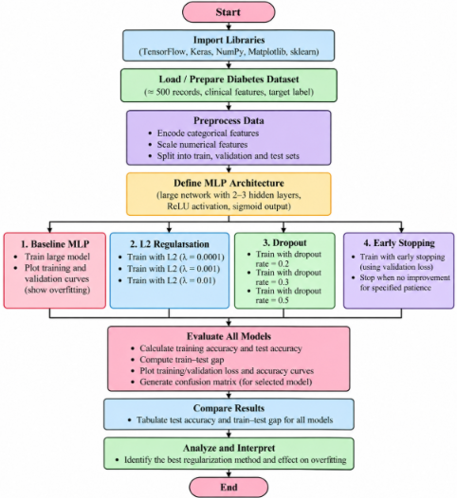

4. Code :

import numpy as np

import pandas as pd

import matplotlib.pyplot as plt

import tensorflow as tf

from sklearn.model_selection import train_test_split

from sklearn.preprocessing import StandardScaler

from sklearn.metrics import accuracy_score

np.random.seed(42)

tf.random.set_seed(42)

n = 500

X = np.random.normal(0, 1, (n, 8))

weights = np.array([

0.8, 0.7, 0.6, 0.5,

0.4, 0.3, 0.5, 0.4

])

logit = X @ weights - 0.2

probability = 1 / (1 + np.exp(-logit))

y = (np.random.rand(n) < probability).astype(int)

print("Dataset Shape:", X.shape)

print("Diabetes Labels:", np.unique(y, return_counts=True))

X_train, X_test, y_train, y_test = train_test_split(

X, y,

test_size=0.2,

random_state=42,

stratify=y

)

scaler = StandardScaler()

X_train = scaler.fit_transform(X_train)

X_test = scaler.transform(X_test)

X_train, X_val, y_train, y_val = train_test_split(

X_train, y_train,

test_size=0.2,

random_state=42,

stratify=y_train

)

def create_model(l2_value=0, dropout_rate=0):

regularizer = tf.keras.regularizers.l2(l2_value)

model = tf.keras.Sequential([

tf.keras.Input(shape=(8,)),

tf.keras.layers.Dense(

128,

activation='relu',

kernel_regularizer=regularizer

),

tf.keras.layers.Dense(

64,

activation='relu',

kernel_regularizer=regularizer

),

tf.keras.layers.Dropout(dropout_rate),

tf.keras.layers.Dense(

32,

activation='relu',

kernel_regularizer=regularizer

),

tf.keras.layers.Dense(

1,

activation='sigmoid'

)

])

model.compile(

optimizer=tf.keras.optimizers.Adam(

learning_rate=0.001

),

loss='binary_crossentropy',

metrics=['accuracy']

)

return model

results = []

histories = {}

def train_and_evaluate(name, model, epochs=150,

early_stopping=False):

callbacks = []

if early_stopping:

callbacks.append(

tf.keras.callbacks.EarlyStopping(

monitor='val_loss',

patience=12,

restore_best_weights=True

)

)

history = model.fit(

X_train, y_train,

validation_data=(X_val, y_val),

epochs=epochs,

batch_size=16,

verbose=0,

callbacks=callbacks

)

train_loss, train_accuracy = model.evaluate(

X_train, y_train, verbose=0

)

test_loss, test_accuracy = model.evaluate(

X_test, y_test, verbose=0

)

gap = train_accuracy - test_accuracy

results.append({

'Model': name,

'Train Accuracy': train_accuracy,

'Test Accuracy': test_accuracy,

'Train-Test Gap': gap

})

histories[name] = history.history

print("\n", name)

print("Training Accuracy:", round(train_accuracy, 4))

print("Test Accuracy:", round(test_accuracy, 4))

print("Train-Test Gap:", round(gap, 4))

print("Epochs Trained:", len(history.history['loss']))

return model

print("\nBASELINE MODEL")

baseline = create_model()

baseline = train_and_evaluate(

"Baseline MLP", baseline

)

l2_values = [0.0001, 0.001, 0.01]

for value in l2_values:

tf.keras.backend.clear_session()

tf.random.set_seed(42)

model = create_model(l2_value=value)

train_and_evaluate(

f"L2 Lambda = {value}", model

)

dropout_values = [0.2, 0.3, 0.5]

for rate in dropout_values:

tf.keras.backend.clear_session()

tf.random.set_seed(42)

model = create_model(dropout_rate=rate)

train_and_evaluate(

f"Dropout = {rate}", model

)

tf.keras.backend.clear_session()

tf.random.set_seed(42)

early_model = create_model()

early_model = train_and_evaluate(

"Early Stopping",

early_model,

epochs=150,

early_stopping=True

)

history = histories["Baseline MLP"]

plt.figure(figsize=(9, 5))

plt.plot(history['loss'], label='Training Loss')

plt.plot(history['val_loss'], label='Validation Loss')

plt.xlabel("Epochs")

plt.ylabel("Binary Cross-Entropy Loss")

plt.title("Baseline MLP - Overfitting Analysis")

plt.legend()

plt.grid()

plt.show()

result_df = pd.DataFrame(results)

print("\nMODEL PERFORMANCE COMPARISON")

print(result_df.round(4).to_string(index=False))

plt.figure(figsize=(12, 6))

x = np.arange(len(result_df))

width = 0.35

plt.bar(

x - width/2,

result_df['Train Accuracy'],

width,

label='Training Accuracy'

)

plt.bar(

x + width/2,

result_df['Test Accuracy'],

width,

label='Test Accuracy'

)

plt.xticks(

x,

result_df['Model'],

rotation=45,

ha='right'

)

plt.ylabel("Accuracy")

plt.title("Regularization Techniques Comparison")

plt.legend()

plt.tight_layout()

plt.grid(axis='y')

plt.show()

plt.figure(figsize=(11, 5))

plt.bar(

result_df['Model'],

result_df['Train-Test Gap']

)

plt.xlabel("Regularization Method")

plt.ylabel("Train-Test Accuracy Gap")

plt.title("Overfitting Reduction Comparison")

plt.xticks(rotation=45, ha='right')

plt.grid(axis='y')

plt.tight_layout()

plt.show()

5. Output
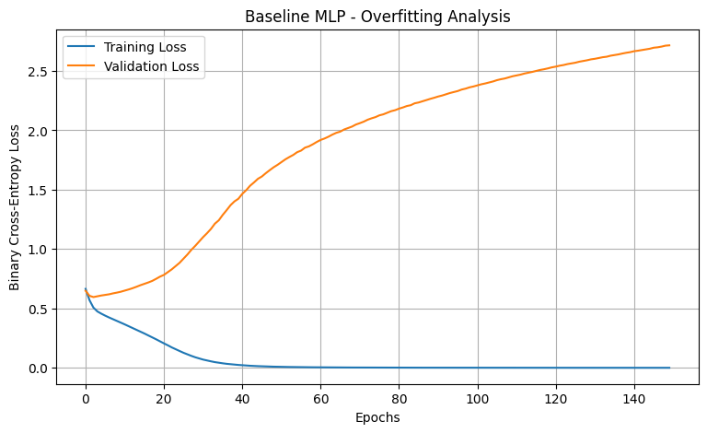
MODEL PERFORMANCE COMPARISON

Model Train Accuracy Test Accuracy Train-Test Gap
Baseline MLP 1.0000 0.58 0.4200
L2 Lambda = 0.0001 1.0000 0.61 0.3900
L2 Lambda = 0.001 1.0000 0.55 0.4500
L2 Lambda = 0.01 0.9875 0.58 0.4075
Dropout = 0.2 1.0000 0.63 0.3700
Dropout = 0.3 1.0000 0.61 0.3900
Dropout = 0.5 0.9906 0.56 0.4306
Early Stopping 0.7906 0.68 0.1106

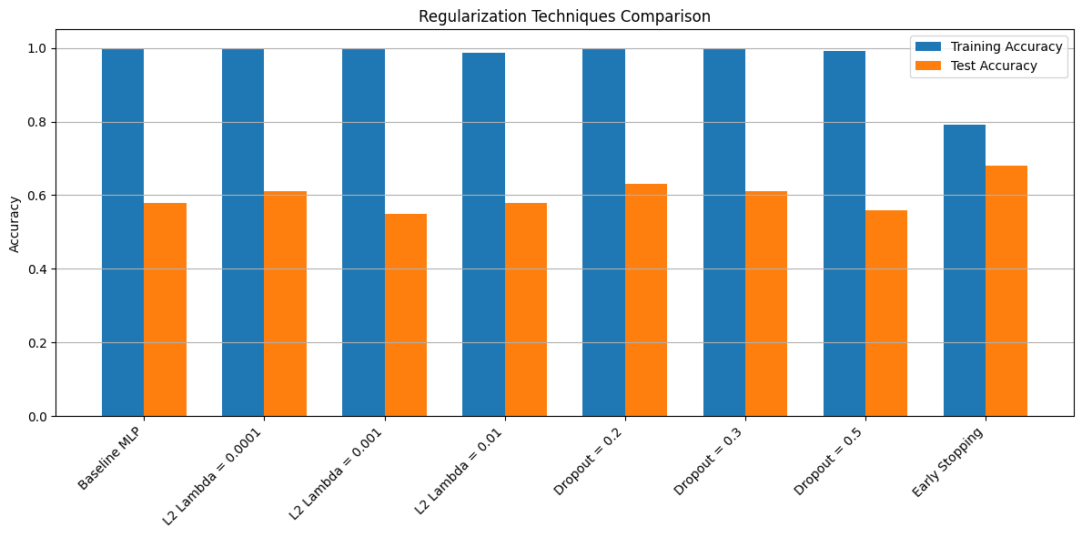

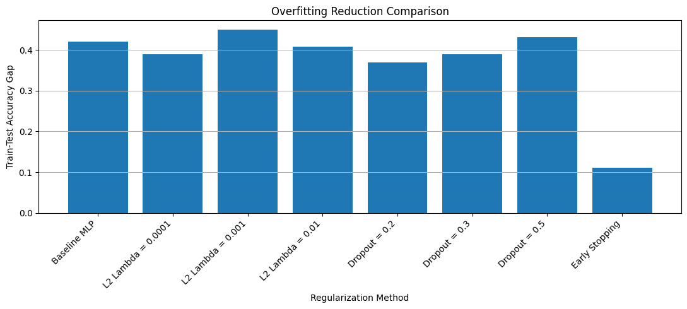

6. Result
An MLP model was successfully implemented for diabetes prediction. L2 regularization, dropout and early stopping were applied and compared with the baseline model. Training and test accuracy, train–test gap and loss graphs were analyzed to study their effectiveness in reducing overfitting.

